H.E Beriault Catholic Junior High School Council
Meeting for November 30, 2023
In Attendance:
Parent Members | Staff Members
Chidi Iwuchukwu – Treasurer | Leon Vandendooren (Principal)
Fern Brewer - Secretary | Nicole Rolph-DeVicque
Taneya Aaron - Not in Attendance

1. Call to Order: Fern
2. Welcoming and Opening Prayer: Opening Prayer offered by Leon
Prayer for Peace: Loving Father, you sent your Son into the world to redeem us by his Cross and Resurrection. Send your Spirit upon us to make us stewards of your gifts and witnesses of your Son, Jesus Christ, in our schools and in our world. Today, we pray for peace. We recall in sadness the crisis in the Middle East that erupted over the weekend when hundreds of people were killed, and thousands injured following the early Saturday morning rocket fire.
In our despair in the midst of hate, in our sense of helplessness in the face of violence, we lean on you. We pray for those impacted by the escalating conflict, for the victims of the tragic crisis, their families and friends, the injured, and the displaced. Isaiah 55:8 reminds us that our thoughts are not your thoughts – and that our ways are not your ways. When we are struggling to see clearly, remind us that we are not alone. Give us the wisdom to hear your voice, and the firm footsteps to follow your path. Come live in our hearts and console us with your love and compassion.
3. Treaty 6 Acknowledgement: Offered by Nicole R
We acknowledge that we are on the traditional land of Treaty 6 and home of the Otipemisiwak (O-ti-pem-se-walk) Metis Government District 9. We also acknowledge the Inuit and other diverse peoples whose ancestors have marked this territory for centuries, a place that has welcomed many peoples from around the world to make their home here.

We, at Edmonton Catholic Schools, commit to restoring and honouring the Truth and Reconcilation calls to action; we strongly believe that truth must be acknolwedge to move forward to reconcilation. Together wecall upon our collective communities to build a stronger understanding of all peoples who dwell on this land we call home.

4. Review/Approval of Meeting Minutes:
- Fern
5. Treasurer’s Report:
- General Account currently at $2622.55
- Casino Account currently at $101251.37
6. New and Continued Business
- School Financial Update Nov. 24/2023
- Introduction to New Assistant Principal
  - Mrs. R

- Assurance Measure Results
- Satisfaction Survey
- PAT Results

- Staffing Update
  - Jordan Weeres (Braided Journeys Cultural Liasion) Mon-Wed
7. Principal’s Report:
- Current Enrollment:
  - 432
- School Activities:
  - Senior/Junior Volleyball ongoing – Curling team just started up last week
  - Basketball tryouts 2nd week of December
  - Face2Face Ministries Gospel message to our Gr 8’s/9’s
  - Artist in Residence Dec. 11-15th grant funding helped us with this.
  - Request for funding (technology -another chrome book cart)
  - Request for funding (Instruments – please see pricing)
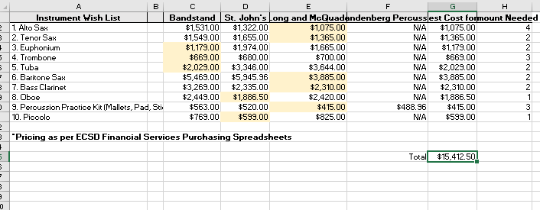

Chromebook Purchase:

HP Chromebook Part # 3V2Y2UTBundle/UQ996E
Unit Price = $ 457.00 x 36 = $ 16452.00
+ GST = $ 822.60
= $ 17274.60

Chromebook Cart Unit Price =$ 2275.00
+ GST = $ 113.75
= $ 2388.75

Total Purchase Price = $17274.60 + $2388.75 = $19 663.35

8. Next Meeting: January 18th 6:30 pm (Teams offered as well once again)
9. Meeting Adjourned: Meeting adjourned at ____________.

